CUSTOMER CARE REGISTRY

DATA FLOW DIAGRAM & USER STORIES

**Team Details:**

Team No : PNT2022TMID05304

College Name : PSNA College of Engineering and Technology

Department : Electronics and Communication Engineering

**Team Members:**

* Rishikeshvar Ram V
* Rajkishore G
* Santhosh Kumar P
* Sasidaran G

PROJECT DESIGN PHASE-II DATA FLOW DIAGRAM & USER STORIES

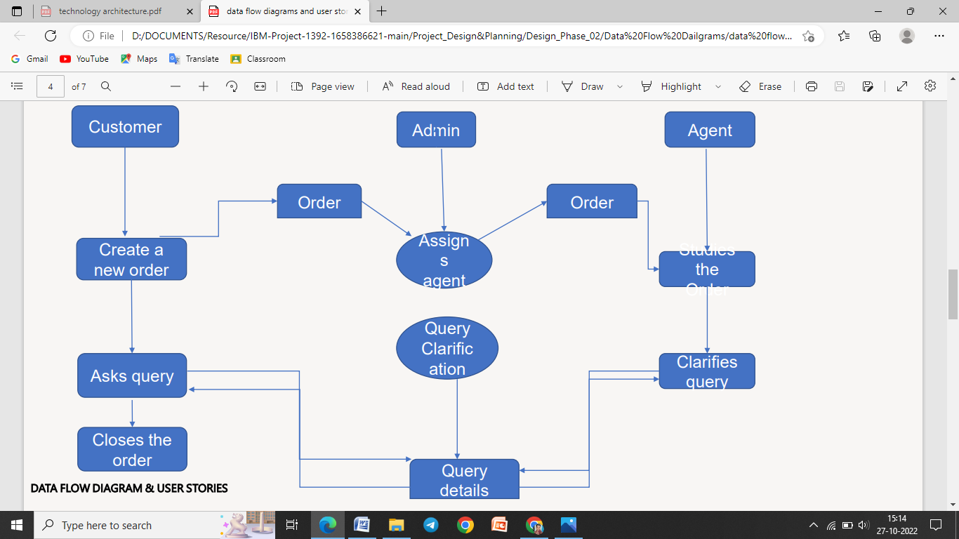

USER STORIES

Use the below template to list all the user stories for the product.

